
Saturday 7 March 2026
New Plymouth Yacht Club, Oceanview Parade, Ngāmotu Beach, New Plymouth

Panui 3 Race Tees

Race Tee

Sneak preview of this year’s race shirt as we finalise sponsors.

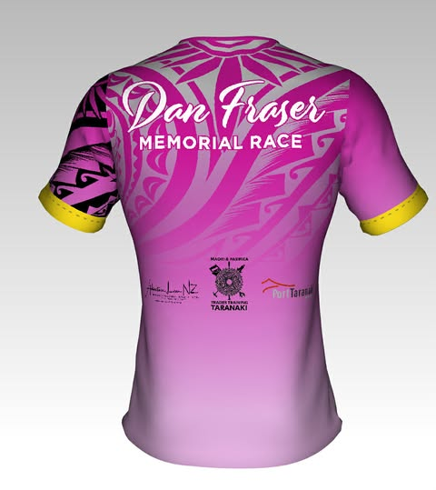

We are going NZ made and is in the softer higher grade fabric.

We have a short window for pre order available to get stock here in time for race day collection so close off is Wednesday 18th February. - close off at 9pm.

Shirts will be available to buy and order on race day too.

Sizes are
- Male
S M L XL XXL XXL etc
- Ladies
8 10 12 14 16 18 20 22 24

Kapinua sizing guide

How to Order

Cost $65

Please contact Karen with order on 027 241 3881

Please pay by direct credit to:
Taranaki Outrigger Canoe Club
15 3953 0774834 003

Please put the following details to identify your payment:

Payment Identifiers | Required info
Particulars - | Your Name
Code - | Size ordered
Reference - | Race Tee

Key Contacts

Any other queries:
Race Admin: Rosie Johnson, 027 7567174, info.taranakiocc@gmail.com
Event Team: Nikyla Fraser 021 375 537
Event Co-ordinator: Karen Bergman Sutton 027 241 3881
Race Director: Steve Outwin, 022 430 2067

